Justin Blackwood, Ethan Elmenhurst, Nathan TeGrotenhuis, Josiah Donor, Kristin Beltz
Design Document

Introduction

This is a system for providing real-time energy usage tracking for residence halls located on the Whitworth University campus. The goal is to encourage energy conservation among students by creating greater awareness. This project will focus on updating the website interface, improving database queries and data storage, testing the data received from the meters, and caching data for faster load time.

The design techniques used in this document will include informal specification, UML diagrams, a structure chart, detailed module designs, and screen shots. The informal specification is used to add more detailed explanation to other diagrams. The UML diagram will help to visualize all of the classes and methods and their interactions. The structure chart will provide a basic overview of how the modules in the system work together, and the detailed module designs will provide a high-level view of the basic structure of the classes and functions. The screenshots reveal the current user interface as well as anticipated changes.

The CASE tools used include Microsoft Word, Visio, Google Docs, and Paint. The word processor is used to write specifications. Visio is used to create the UML and other diagrams. Google Docs is used to share our design document between team members. Paint is used to add features to the user interface screen shots.

Code Style Guide
C#
Use tab indents. Start static variables with an underscore like “_static”. Functions and Class names should be capitalized CamelCase like “ClassName”. Functions definitions should look like this:
FunctionName( parameter1, parameter2 )
{
code
}
The opening parenthesis should immediately follow the function name. Next comes a space. Parameters are separated by “, “ and a space should follow the last parameter before the closing parenthesis. Brackets should align with the function name without any extra whitespace. Code inside the definition begins on a newline and is tab-indented.

Conditional and looping blocks should look like this:
if( var == cond )
{

}

NamesShouldBeVerboseWeHaveIntellisense but keep names of functions, variables, and classes to 4 words or less. If you can't describe what you're making in 4 words or less expand your vocabulary or make something simpler.

Documentation: use Attributes “[ ]” to document every class. Don’t spend too much time on this, but put in enough to give a person reading your code a first step to figure out what’s going on.
Use /// for each public function with a brief summary of usage. We want to take full advantage of our IDE.

Function names should be verbs.
Variable names should be nouns.
Collections should be plural.
Classes should be singular nouns.
CONSTANTs should be defined in all caps and global constants should be put into their own class!

One or 2 line comments use ‘//’
more than 2 line comment use /* */

SQL:
ALL KEYWORDS SHOULD BE IN ALL CAPS.

SELECT
FROM
WHILE
…
Each statement in a query should be on its own line.
End each query with a semicolon.

Ruby enforces many style features. Ruby has whitespace line endings. Capitalize constants. Use CamelCase for function and variable and class names.
Use the same spacing style and indent style as C#.
Use 2 space indents.

System Architecture

System Requirements:
Our first requirement is a linux server to house the powerstorm database and host the website. This must have MySQL, Ruby, Ruby on Rails, NGINX, and mono installed on it.
Next we will need the beagleboards which have ARM processors, VNC X11, Python, and several custom startup scripts. We will use Arduino and Darlington Pair Arrays to help use pulse with modification.
Finally, a client will be needed which could be any computer to connect to the website.
Hardware Assumptions:
A virtual machine running on a Whitworth server having at least 20 GB of hard drive space for our server.

High-Level Design

Structure Chart:
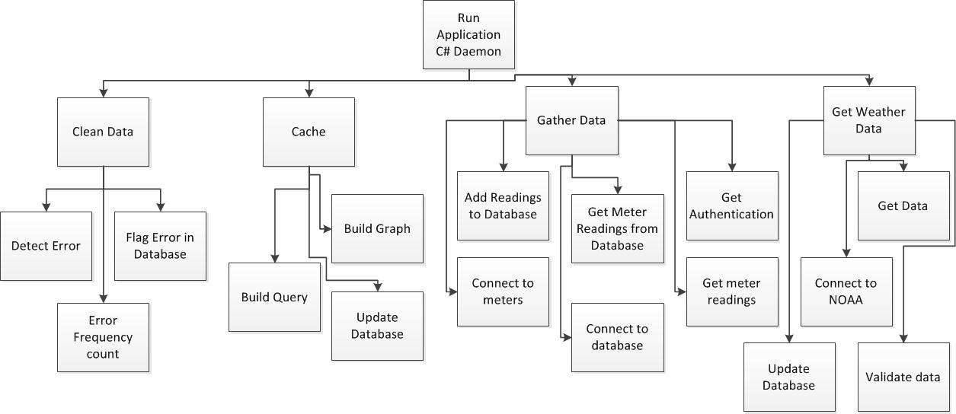

Updated structure chart:

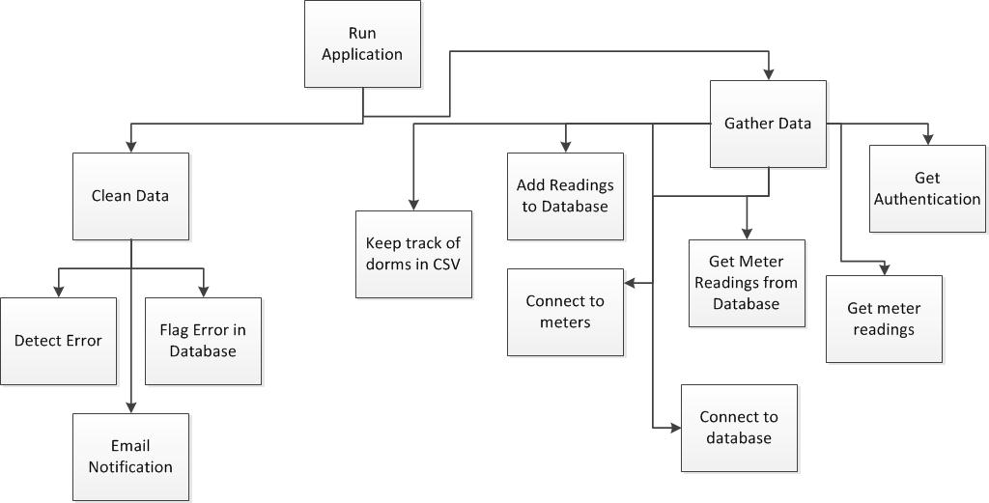

Detailed module designs:

Module Name | run application (Program)
Module Type | function
Return Type | none
Input Arguments | none
Output Arguments | none
Errors | bad database connection
Files Accessed | none
Files Changed | none
Modules Called | clean data, service performance, gather data, get weather data
Modules Called By | none
Narrative | Controls the calling of modules. Is set to run on a loop that executes every five minutes. Each loop calls the sub modules for each building/data set collected.

Module Name | DataCleaner()
Module Type | class
Return Type | none
Input Arguments | none
Output Arguments | none
Errors | bad database connection, non-existent data
Files Accessed | database
Files Changed | database
Modules Called | detect error, flag error in database, error frequency count
Modules Called By | run application
Narrative | Reads data from database, determines whether or not the data is an outlier, updates database, keeps track of number of errors

Module Name | CleanData()
Module Type | function
Return Type | int
Input Arguments | none
Output Arguments | none
Errors | bad data, bad database connection
Files Accessed | database
Files Changed | database
Modules Called | none
Modules Called By | clean data
Narrative | Gets the new data point from the database, get previous data points, calculates standard deviation, determines if new point is an outlier. Updates flag in the database.

Module Name | Program
Module Type | Class
Return Type | N/A
Input Arguments | N/A
Output Arguments | N/A
Errors | SQL Exeception
Files Accessed | myFile.txt

Module Name | main
Module Type | Function - main
Return Type | Void
Input Arguments | String[] args
Output Arguments | NONE
Errors | NONE
Files Accessed | NONE
Files Changed | NONE
Modules Called | Constructor (Program())
Modules Called by | NONE
Narrative | Starts everything by creating new Program()

Module Name | Program()
Module Type | Function - Constructor
Return Type | NONE
Input Arguments | NONE
Output Arguments | NONE
Errors | NONE
Files Accessed | myFile.txt
Files Changed | NONE
Modules Called | PromptForAuthentication(), FetchReadings()
Modules Called by | Main
Narrative | Forces the authentication and then locks in loop retrieving data every five minutes

Module Name | SqlGetEnvisionReadings
Module Type | Function
Return Type | String
Input Arguments | Int meterId, int maxHoursToRetreive, DateTime from, DateTime until
Output Arguments | NONE
Errors | NONE
Files Accessed | NONE
Files Changed | NONE
Modules Called | NONE
Modules Called by | FetchReadings()
Narrative | Creates the Select SQL String to retrieve data from an Envision Database

Module Name | SqlInsertReading
Module Type | Function
Return Type | NONE
Input Arguments | int meterId, DateTime timeOfReading, double reading
Output Arguments | NONE
Errors | NONE
Files Accessed | NONE
Files Changed | NONE
Modules Called | NONE
Modules Called by | FetchData()
Narrative | Inserts data into powerstorm database

Module Name | PromptForAuthentication
Module Type | Function
Return Type | NONE
Input Arguments | No function arguments. Console Input for username/password
Output Arguments | Console Output prompts for username/password
Errors | NONE
Files Accessed | NONE
Files Changed | NONE
Modules Called | Constructor
Modules Called by | NONE
Narrative | Gets login information to connect to Envision Database

Module Name | ConnectEnvision()
Module Type | Function
Return Type | NONE
Input Arguments | NONE
Output Arguments | NONE
Errors | NONE
Files Accessed | NONE
Files Changed | NONE
Modules Called | NONE
Modules Called by | FetchReadings()
Narrative | Connects to the Envision Database

Module Name | ConnectPowerStorm()
Module Type | Function
Return Type | NONE
Input Arguments | NONE
Output Arguments | NONE
Errors | NONE
Files Accessed | NONE
Files Changed | NONE
Modules Called | NONE
Modules Called by | FetchReadings()
Narrative | Connects to the PowerStorm Database

Module Name | FetchReadings()
Module Type | Function
Return Type | NONE
Input Arguments | NONE
Output Arguments | NONE
Errors | SqlError
Files Accessed | myFile.txt
Files Changed | NONE
Modules Called | ConnectPowerStorm(), ConnectEnvision(), SqlGetEnvisionReadings(), SqlInsertReading()
Modules Called by | Constructor
Narrative | The heart of the program. It causes the connection to both databases to be activated and copies information between them.

Module Name | Keep track of dorms in csv
Module Type | Function
Return Type | NONE
Input Arguments | Name of dorm, CSV index
Output Arguments | Name, reading info, index
Errors | IOException
Files Accessed | lastDormReading.csv
Files Changed | lastDormReading.csv
Modules Called | none
Modules Called by | Constructor
Narrative | The heart of the program. It causes the connection to both databases to be activated and copies information between them.

Low-Level Design

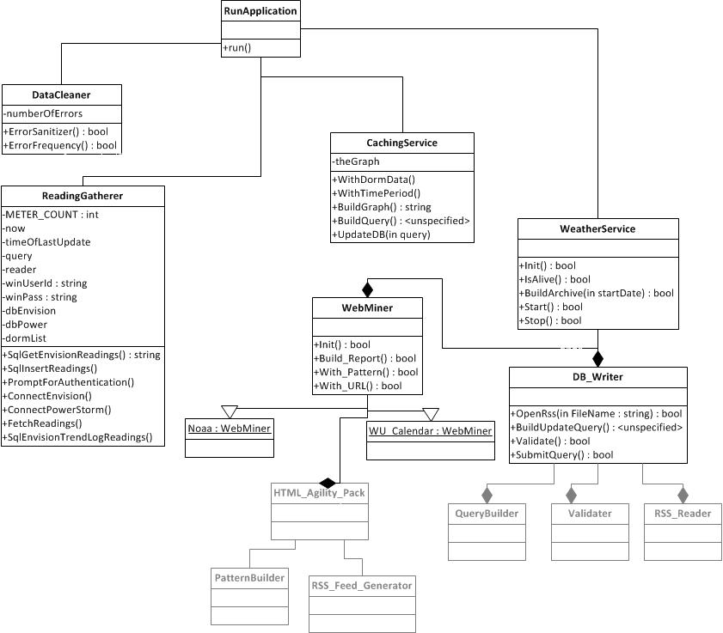

Updated UML:
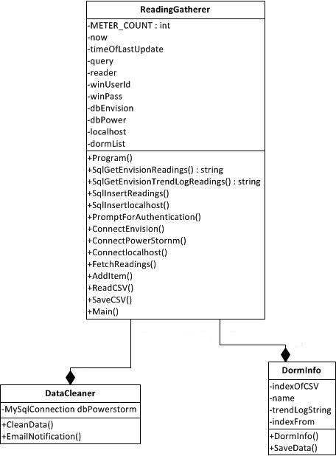

DataCleaner (clean data module)

This class will have an attribute named dbPowerstorm, which keeps track of the connection to the database. The class will call CleanData() first If, in CleanData(), an outlier if detected, EmailNotification() is called. CleanData will read values from the database, test for outliers, mark values as ‘alarmed’ (meaning it is an outlier), look for alarmed values, and attempt to use linear regression to clean the value.

void CleanData() (detect error module)

This will loop through all of the buildings/data sets in the database, retrieving the new data value as well as the old values. It will calculate the standard deviation, and determine if the point is an outlier. If it is, it will update the flag in the database for that value to indicate that the point is an outlier. It will then clean any marked values in the database based on the surrounding values.

void EmailNotification(string msg)

This will send an email notification with information of the error if a value is marked as alarmed (meaning there is a standard deviation), in the database.

Reading Gatherer
Class Program:

State Variables:
const int METER_COUNT = 4
DateTime now
DateTime timeOfLastUpdate
SqlCommand query
SQLDataReader reader
String winUserId
String winPass
SqlConnection dbEnvision
MySqlConnection dbPower
public List <dormInfo> dormList

Methods:
Constructor:
Calls: readCSV(), PromptForAuthentication(), FetchReadings(), savCSV()
Purpose: Read in the settings from the “lastDormReading.csv” which stores the {Dorm Name, Table Name, Last Index Read}. The PromptForAuthentication method logs the computer into a user’s credentials, right now that is using Patrick Yoho’s network login. The FetchReadings method retrieves the newest readings from the dbEnvision database to be stored in the dbPower database. Next, the settings are saved to the “lastDormReading.csv.” Lastly, we pause for five minutes to allow more data to be read to the dbEnvision database.

String SqlGetEnvisionTrendLogReadings(string trendlog_id, int index_from)
Returns: The SQL Query String
Parameters:
trendlog_id: name of the table to be read from
index_from: retrieve all of the new readings since the index last read from.
Purpose:
Creates an SQL query string, does not connect to database.
Form:
SELECT * FROM trendlog_id WHERE [Index] > index_from AND [ValueType] = 2

void SqlInsertReading(int meterId, dateTime timeOfReading, double reading)
Returns: NONE
Parameters:
MeterId: meterId See SqlGetEnvisionReadings->meterId for more information
timeOfReading: Time in yyyy-MM-dd HH:mm:ss format
Purpose: Calls an insert passing the data from the meters database (dbEnvision) into a more general database used by Powerstorm (dbPower).
Form: INSERT INTO electricity_readings (meter_id, date_time, power) VALUES (meterId, CAST(‘timeOfReading.ToString(‘yy-MM-dd HH:mm:ss’) AS DATETIME), reading)

void PromptForAuthentication()
Returns: NONE
Parameters: NONE
Inputs (Console): Username and password as winUserId and winPass respectively. This currently uses Patrick Yoho’s network login information to connect to WhitStudent.
Purpose: Sets up proper connection strings for the Envision database

void ConnectEnvision()
Returns: NONE
Parameters: NONE
Purpose: sets up connection string to the Envision database
NOTE: redundant code suggest consolidating code in PromptForAuthenication by calling ConnectEnvision

void ConnectPowerStorm()
Returns: NONE
Parameters: NONE
Purpose: Creates the MySQL connection string used to connect to the database used by PowerStorm (dbPower).

void FetchReadings()
Calls: ConnectPowerStorm, ConnectEnvision, GetEnvisionReadings, SqlInsertReading
FileWriting: Writes the time it finishes
Purpose: Connector function which causes the cascade of retrieving the data from Envision and inserting it into the Powerstorm database

void addItem(int indexOfCSV, string Name, string trendLogString, int indexFrom)
Returns: NONE
Parameters: indexOfCSV, Name, trendLogString, indexFrom

Static void Main (string[] args)
Calls: Constructor
Purpose: Starts up everything through the constructor

Overall Notes:
Current ReadingGather.cs does not conform to our current coding guidelines. For example constants in a class and indentation. Some code can easily be refactored to prevent reuse.

For loop in SQLGetEnvisionReadings has poorly constructed for loop. No file handling in constructor and try catch for sqlInsertReading.

Note: this does not exist in our final project
CachingService
Class: CachingService

State Variable:
gRaphaelGraphObject theGraph

void WithDormData(string DormName)
Returns: NONE
Parameters: DormName, the name of the dorm for which the graph will be constructed.
Purpose: Sets the theGraph.dormName equal to the DormName and sends .

void WithTimePeriod(timePeriod TimePeriod)
Returns: NONE
Parameters: TheTimePeriod, specifies what time period the graph will display.
Purpose: Sets the theGraph.timePeriod equal to TimePeriod.

String BuildGraph()
Returns: graph object serialized to a JSON string.
--Check that timePeriod and dormName are set. If not -throw exception.
Purpose: Call gRaphael to create the graph object and serialize it.

SQLPreparedStatement BuildQuery()
Returns: SQLPreparedStatement that represents the SQL query to add the graph in string format to the database.

void UpdateDB(SQLPreparedStatement query)
Returns: NONE
Purpose: Executes the SQL query on the database, inserting the graph into the database.

User-Interface Design

Since there is a user interface already in place in the existing project that the client is at least mostly satisfied with, our work in this area will be focused on iterative improvements to the existing interface, while preserving the existing look and feel. Currently there are three main screens in the product: the home screen, the basic building view, and the advanced building view.

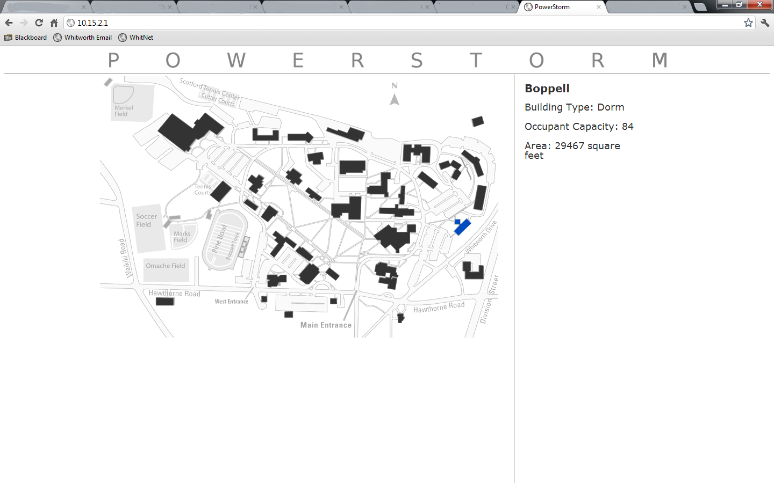

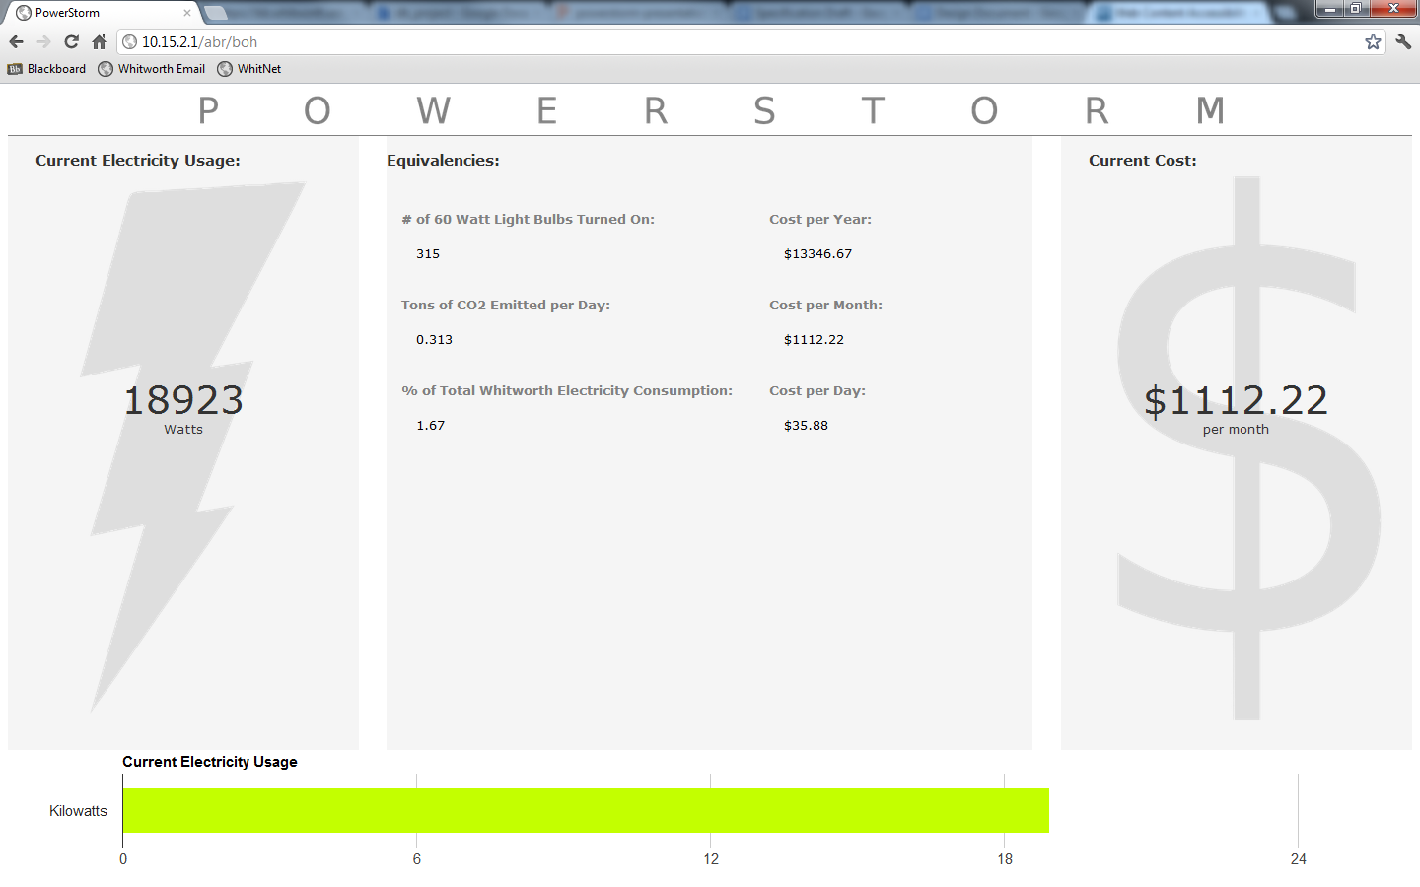

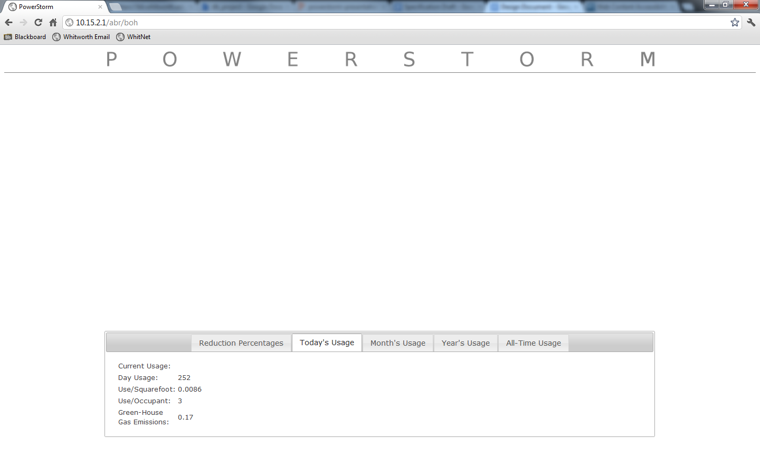

These screens handle selection of building (home screen), viewing of basic details about a building’s power usage (basic building screen), and viewing of more advanced details about a building’s power usage (advanced building screen). Currently the advanced page is not displaying graphs, which is an issue we are looking into.

One of the main improvements we would like to focus on is navigation. Currently it is not clear how to navigate around the application due to inconsistent and confusing placement of navigation buttons. The main navigation buttons are hidden behind the word “Powerstorm” at the top of the screen and only become visible when the mouse hovers over.

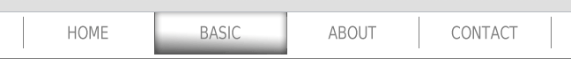
This navigation style is confusing and unnecessary both because there is no way of knowing it is there without accidentally hovering over the top bar, and because the about and contact pages each have only one line of relevant information. We will remove this hover behavior entirely and make the Powerstorm bar simply be a link to the home page. The about and contact info will be condensed into a small addition to the bottom of the home screen under the map. Something along these lines:

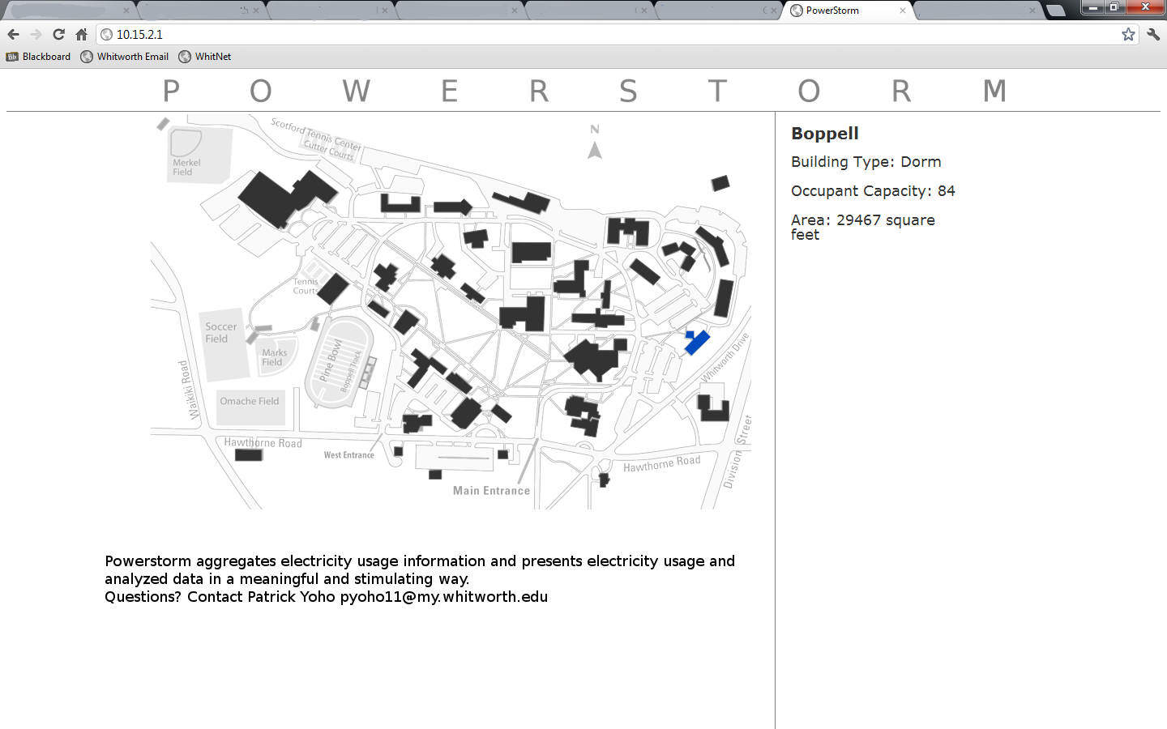
This will alleviate the concerns about the top navigation bar while preserving all of the information that was accessible. However, we must now deal with the Basic/Advanced button. This button was also housed in the top navigation bar but only on the basic/advanced pages, not the home page. This is an issue because even if a user had stumbled upon the top navigation on the home page, they would not be aware that an extra button was present in the navigation on the detail pages. Since we are removing the navigation in the top bar, we will move this toggle functionality to be housed on the basic/advanced pages themselves.

Another addition to the basic/advanced pages we will make is an indication of which building is currently being viewed. Currently, there is no such indication and so there is no way for the user to know which page they are on or to verify that they clicked on the building that they wanted. A simple heading at the top of the page should alleviate this issue. This is a very rough mockup of these ideas:
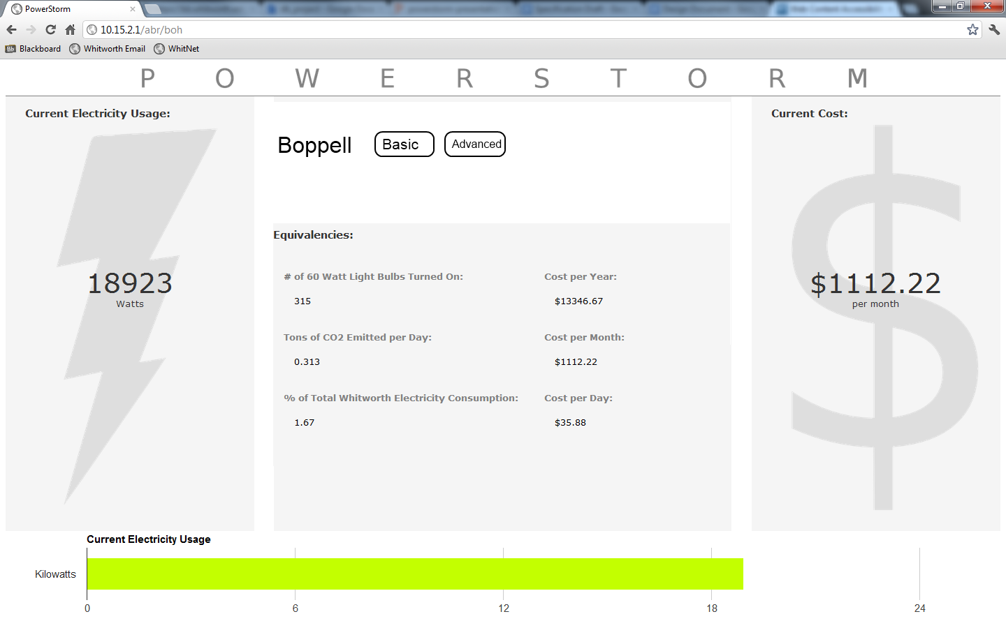
These are the main improvements we would like to focus on: removing the top navigation, condensing the about and contact pages into text on the home page, and adding indication of which dorm is currently being viewed and the basic/advanced view buttons to the detail pages. These items are pending review with the client, so changes may be made.

Testing

Each person reviewed the design document as a whole, focusing on his or her specific section. We had to update the UML and structure chart several times to accommodate unanticipated changes to the design of the classes. We also added more detail to our function and class descriptions as we created a more in depth design.

In the specification document, we created an initial UML for our project. Much of the same structure still exists in this document, but we did have to edit and add more detail to many of the classes. In the specification, we had the basic idea of the structure of the project, but this document allowed us to more accurately portray the design.

